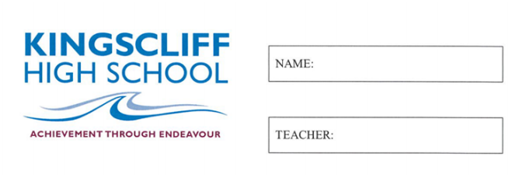

MATHEMATICS

Year 7

Practice Exam 1

2026

Time allowed: 50 mins
5 mins reading time
Instructions  1. Attempt all questions  2. Show working where needed  3. A calculator is NOT permitted |  | Sections and Marks  Part A (Multiple Choice) – 15 Marks  Part B (Calculations) – 30 Marks  Part C (Data and Probability) – 18 Marks  Total – 63 Marks

Part A
1. | Which word describes the value that occurs most often in a set of data?  a) Mean b) Median  c) Mode d) Range
2. | The range of the data 4, 9, 2, 12, 7 is:  a) 7 b) 10  c) 12 d) 2
3. | Using the order of operations, which part of 18 − 3 × (2 + 4) is worked out first?  a) 18 − 3 b) 3 × 2  c) 2 + 4 d) 4 × 18
4. | Which list is written in descending order?  a) 3, 8, 11, 15 b) 15, 11, 8, 3  c) 8, 3, 15, 11 d) 11, 15, 3, 8
5. | In the number 3.462, what is the place value of the digit 6?  a) Tenths b) Hundredths  c) Thousandths d) Ones
6. | What does 5⁴ mean?  a) 5 × 4 b) 5 + 5 + 5 + 5  c) 5 × 5 × 5 × 5 d) 4 × 4 × 4 × 4 × 4
7. | In the expression 6 + p, the letter p is:  a) Always equal to 6  b) A variable – a letter that stands for a number  c) A unit of measurement  d) The answer
8. | The three angles inside any triangle always add up to:  a) 90° b) 180°  c) 300° d) 360°
9. | Which triangle has exactly two equal sides and two equal angles?  a) Scalene b) Equilateral  c) Isosceles d) Right-angled
10. | A rectangle is 5 cm long and 3 cm wide. Its perimeter is:  a) 8 cm b) 15 cm  c) 16 cm d) 30 cm
11. | Which of these numbers is the smallest?  a) −9 b) −2  c) 0 d) 4
12. | A standard six-sided die is rolled. Which is the sample space?  a) {1, 2, 3} b) {6}  c) {1, 2, 3, 4, 5, 6} d) {0, 1, 2, 3, 4, 5, 6}
13. | In probability, P(E) stands for:  a) The perimeter of E  b) The probability of event E happening  c) The power of E  d) The place value of E
14. | An angle of 135° is:  a) Acute b) Right  c) Obtuse d) Reflex
15. | Alternate angles on parallel lines are:  a) Equal  b) Supplementary (add to 180°)  c) Complementary (add to 90°)  d) Always 90°

Part B
1. | Calculate the missing angle and provide working out. | 2  marks
  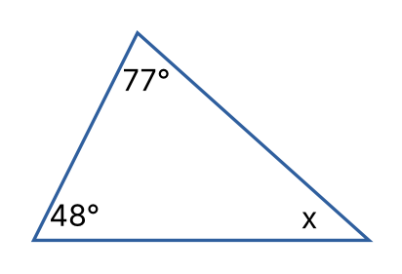 | _____________________  _____________________  _____________________  _____________________
2. | Calculate the size of the exterior angle marked a° and provide working out. | 2  marks
  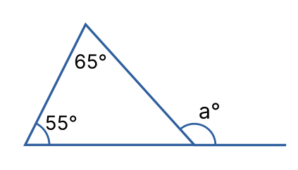 | _____________________  _____________________  _____________________  _____________________
3. | State True or False for each of the following:  a) 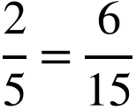 b) 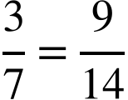 | 2  marks
4. | Calculate the following:  a) 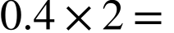 b) 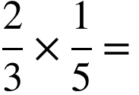 | 2  marks
5. | Calculate the following:  a) 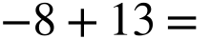  b) 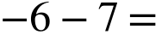  c) 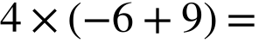 | 3  marks
6. | Convert into a mixed number:  a) 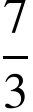  Convert into an improper fraction:  b) 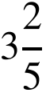 | 2  marks
7. | Write an algebraic expression for each statement. Use to represent the number:  i) 5 more than the number  ii) The number divided by 4 | 2  marks
8. | If 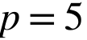, 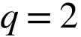 and 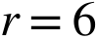  Solve the following by substitution:  i) 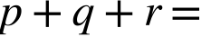  ii) 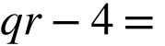 | 2  marks
9. | Simplify the following:  i) 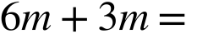  ii) 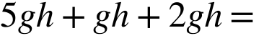  iii) 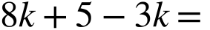  iv) 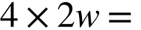 | 4  marks
10. | Calculate the following (use a mental or written strategy):  i) 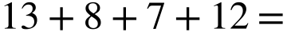  ii) 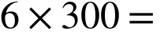  iii) 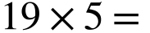 | 3  marks
11. | Solve the following equations:  i) 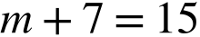  ii) 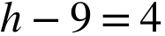  iii) 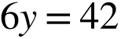  iv) 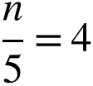  v) 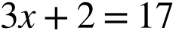  vi) 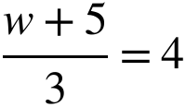 | 6  marks

Part C
12. | The following list shows the number of books Mia read each month over two years:  3 1 2 4 3 2 5 3 1 2 3 4  2 3 10 2 3 4 1 3 2 3 4 2  i) Construct a dot plot from the above set of data  ii) How many months are shown in the data?  iii) What is the mode?  iv) What is the range?  v) In how many months did Mia read fewer than 3 books?  vi) Is there an outlier? If so, what is it? | 7  marks
13. | Observe the following set of data:  2, 5, 7, 4, 8, 3, 9, 6, 10  Calculate the following:  i) The mean  ii) The median  If 14 was added to the data set, what would be:  iii) The new median?  iv) The new mean? | 4  marks
14. | Observe the following graph and answer the questions below.  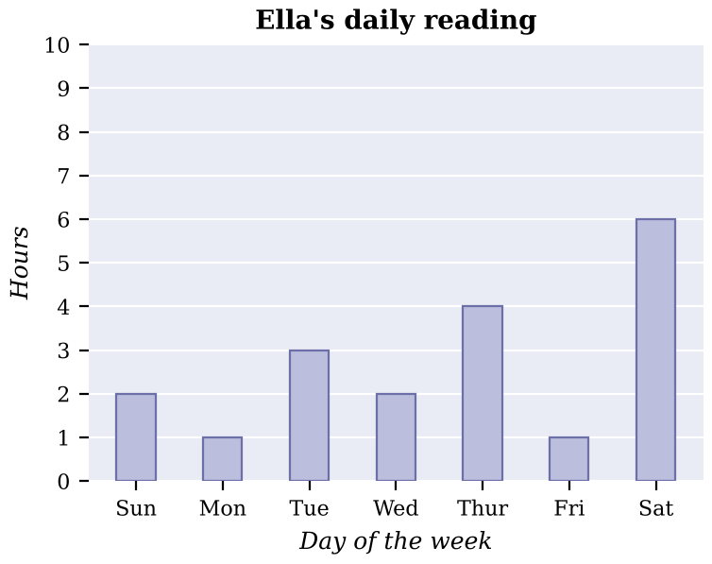  i) How many hours did Ella spend reading on Thursday?  ii) On which day did Ella spend the most time reading?  iii) How many hours did Ella spend reading over the whole week shown?  iv) What fraction of Saturday did Ella spend reading? Give your answer in simplest form. | 4  marks
15. | 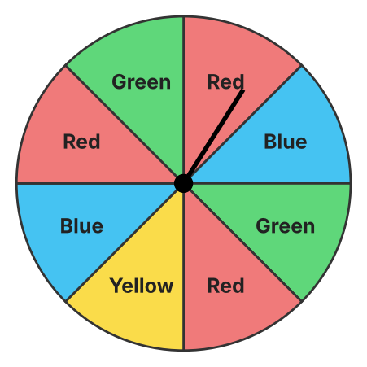  Observe the spinner above. Each section is the same size.  a) List the sample space:  b) What is the probability of spinning red?  c) What is the complement of spinning blue, and what is its probability? | 3  marks

